Assignment – 2

1. **public** **class** Single {

**private** **static** Single *t*=**new** Single();

**private** Single ()

{

}

**public** **static** Single getSingle()

{

**return** *t*;

}

}

**class** Many **extends** Single

{

}

2.

**package** lamdaexpression;

**class** employee{

**int** salary;

**int** total() {

**return** 0;

}

}

**class** mang **extends** employee{

**int** incentive;

**int** total() {

**return** salary+incentive;

}

}

**class** lab **extends** employee{

**int** over;

**int** total( ) {

**return** salary+over;

}

}

**public** **class** Totalsal {

**public** **static** **void** main(String[] args) {

mang manager = **new** mang();

lab labour = **new** lab();

manager.salary = 10000;

manager.incentive = 2000;

labour.salary= 15000;

labour.over=1000;

**int** Total;

Total=manager.total() +labour.total();

System.***out***.println (Total);

}

}

Output:-

28000

3. **public** **class** Current Current **extends** Bank{

**int** amount;

Current(){

**super**();

amount=0;

}

Current(String n,**int** a,String t)

{

**super**(n,a,t);

amount=a;

}

**int** cashCredit(){

**return**(**super**.totalCash());

}

}

Public **class** Bank{

String name;

**int** amt;

String accountType;

Bank()

{

name=**null**;

amt=0;

accountType=**null**;

}

4.

//private abstract class King {//4th question

//final abstract class King{//5th question.

**abstract** **class** King{

//abstract void queen();//1st question and 6th question

//King obj =new King();//2nd question.

}

**class** Queen **extends** King

{

/* abstract void queen()

{

System.out.println("done");//3rd question.

}*/

}

**class** Main

{

**public** **static** **void** main(String[] args)

{

Queen in = **new** Queen();

in.queen();

}

}

5. **package** lamdaexpression.Assignments;

**abstract** **class** Shape

{

**public** **abstract** **void** draw();

}

**class** Line **extends** Shape

{

**public** **void** draw()

{

System.***out***.println("single dimension");

}

}

**class** Rectangle **extends** Shape{

**public** **void** draw()

{

System.***out***.println("four dimension");

}

}

**class** Cube **extends** Shape

{

**public** **void** draw()

{

System.***out***.println("four dimension");

}

}

**public** **class** Main1 {

**public** **static** **void** main(String[] args) {

{

Line ln = **new** Line();

ln.draw();

Rectangle rn = **new** Rectangle();

rn.draw();

Cube cn=**new** Cube();

cn.draw();

}

}

}

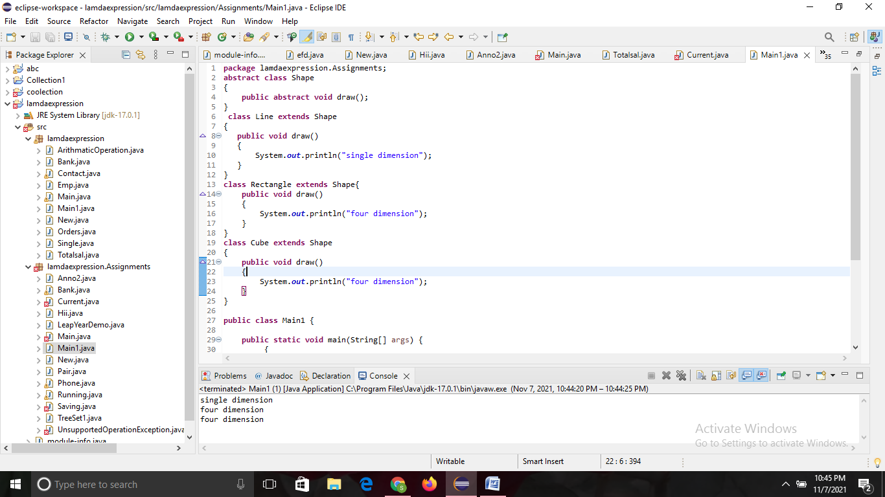

6.

